Bug Report - 11/30/05
Sam McKagan

Conductivity

In Photoconductor mode, when you shine light, some electrons jump up. The electrons in the upper band start moving, as they should, but the electrons in the lower band, which now have free levels to jump to, don’t move. The top electrons in the lower band should also move.

Upper limit on voltage is 2V. If I try typing in a number greater than 2, it just doesn’t respond, rather than giving me an error message, so it seems like the program has a bug.

Semiconductors:

If I open it at 1024x768 screen resolution, it looks like this and is unusable:
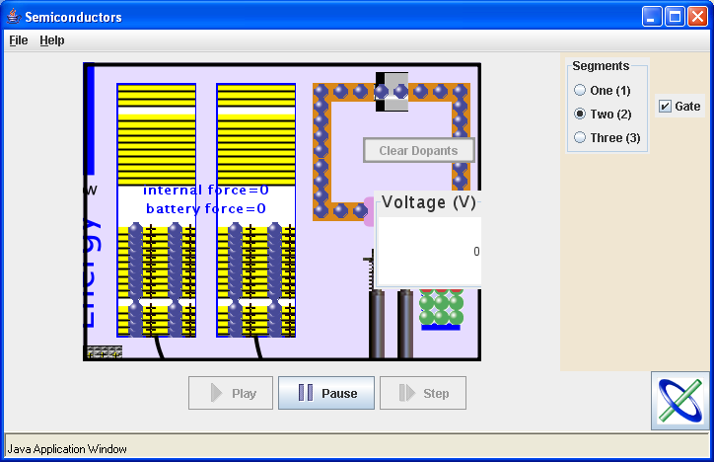
(but if I open it at 1280x1024 and then switch to 1024x768 while it’s still open, it looks fine)

Whenever you add a dopant, it leaves an extra square of dopant lying next to the one you added.

If you have three segments, current doesn’t flow at all through a pn junction, regardless of whether the voltage is positive or negative.

